# Rossmoyne Senior High School

### Semester One Examination, 2015

### Question/Answer Booklet

If required by your examination administrator, please place your student identification label in this box

# MATHEMATICS SPECIALIST 3C

## Section Two:

## Calculator-assumed

|  |  |  |  |  |  |  |  |  |
| --- | --- | --- | --- | --- | --- | --- | --- | --- |
| Student Number: In figures |  |  |  |  |  |  |  |  |

In words

Your name

## Time allowed for this section

Reading time before commencing work: ten minutes

Working time for this section: one hundred minutes

## Materials required/recommended for this section

##### *To be provided by the supervisor*

This Question/Answer Booklet

Formula Sheet (retained from Section One)

##### *To be provided by the candidate*

Standard items: pens (blue/black preferred), pencils (including coloured), sharpener,

correction fluid/tape, eraser, ruler, highlighters

Special items: drawing instruments, templates, notes on two unfolded sheets of A4 paper, and up to three calculators approved for use in the WACE examinations

## Important note to candidates

No other items may be taken into the examination room. It is **your** responsibility to ensure that you do not have any unauthorised notes or other items of a non-personal nature in the examination room. If you have any unauthorised material with you, hand it to the supervisor **before** reading any further.

## Structure of this paper

|  |  |  |  |  |  |
| --- | --- | --- | --- | --- | --- |
| Section | Number of questions available | Number of questions to be answered | Working time (minutes) | Marks available | Percentage of exam |
| Section One:  Calculator-free | 6 | 6 | 50 | 50 | 33⅓ |
| Section Two:  Calculator-assumed | 13 | 13 | 100 | 100 | 66⅔ |
|  | | | **Total** | 150 | 100 |

## Instructions to candidates

1. The rules for the conduct of Western Australian external examinations are detailed in the *Year 12 Information Handbook 2015*. Sitting this examination implies that you agree to abide by these rules.
2. Write your answers in this Question/Answer Booklet.
3. You must be careful to confine your response to the specific question asked and to follow any instructions that are specified to a particular question.
4. Spare pages are included at the end of this booklet. They can be used for planning your responses and/or as additional space if required to continue an answer.

* Planning: If you use the spare pages for planning, indicate this clearly at the top of the page.
* Continuing an answer: If you need to use the space to continue an answer, indicate in the original answer space where the answer is continued, i.e. give the page number. Fill in the number of the question that you are continuing to answer at the top of the page.

1. **Show all your working clearly**. Your working should be in sufficient detail to allow your answers to be checked readily and for marks to be awarded for reasoning. Incorrect answers given without supporting reasoning cannot be allocated any marks. For any question or part question worth more than two marks, valid working or justification is required to receive full marks. If you repeat any question, ensure that you cancel the answer you do not wish to have marked.
2. It is recommended that you **do not use pencil**, except in diagrams.
3. The Formula Sheet is **not** to be handed in with your Question/Answer Booklet.

Section Two: Calculator-assumed (100 Marks)

This section has**thirteen (****13)** questions. Answer **all** questions. Write your answers in the spaces provided.

Working time: 100 minutes.

Question 7 (6 marks)

(a) Determine  if , . (2 marks)

(b) Let .

Show that  and hence determine the exact value of  when . (4 marks)

Question 8 (8 marks)

A curve is defined parametrically as  and , where .

(a) Determine an expression for  in terms of . (2 marks)

(b) Determine the equation of the tangent to the curve when . (4 marks)

(c) Determine the coordinates of the point on the curve where the tangent is parallel to the -axis. (2 marks)

Question 9 (8 marks)

Draw sketches of the following sets of points in the complex plane.

(a)  (3 marks)

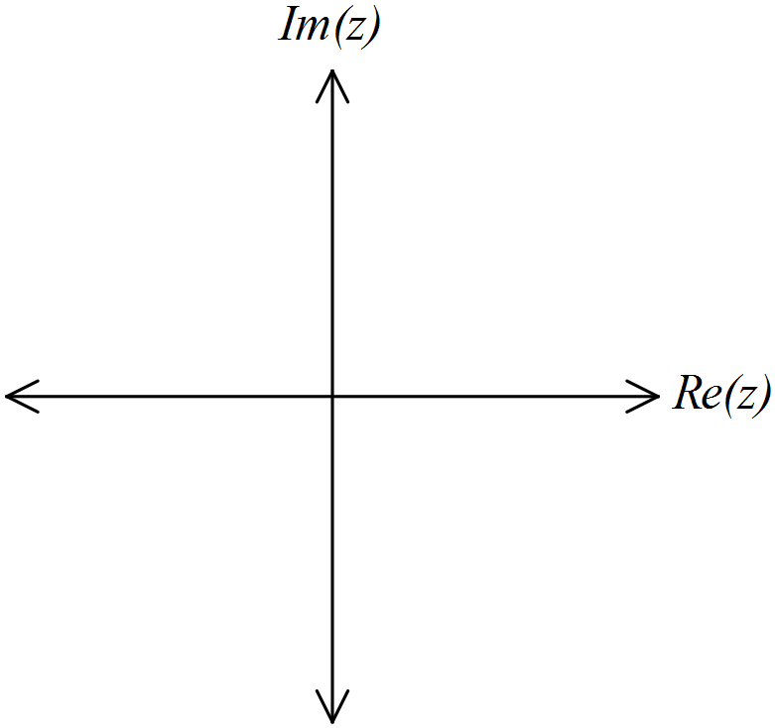

(b)  (2 marks)



(c)  (3 marks)



Question 10 (6 marks)

(a) If , show that . (3 marks)

(b) Determine the gradient of the curve  at the point where . (3 marks)

Question 11 (7 marks)

The points  and  have position vectors  and  respectively.

(a) Determine a vector equation for the straight line passing through  and . (2 marks)

(b) Write your answer to (a) in its parametric equivalent and hence, or otherwise, express the Cartesian equation of the line in the form . (3 marks)

(c) Determine a unit vector parallel to the straight line in (a). (2 marks)

Question 12 (8 marks)

(a) Draw sketches of the polar graphs given by ,  and  on the axes below.

(5 marks)

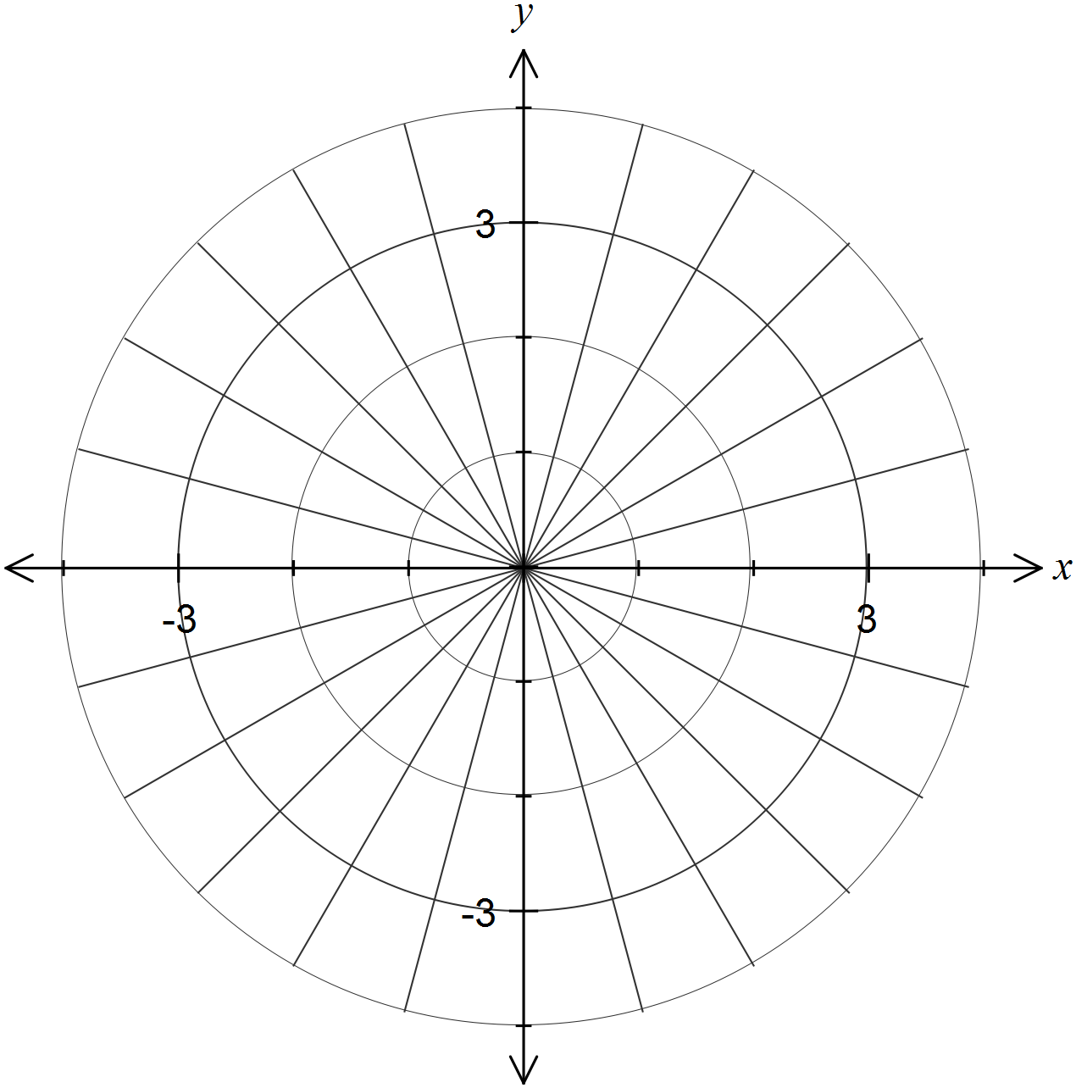

(b) If  is the point of intersection of the graphs of  and , and  is the point of intersection of the graphs of  and , determine the length of .

(3 marks)

Question 13 (9 marks)

A plane  contains the two lines  and .

(a) Write down a vector equation of the plane . (1 mark)

(b) The point  lies in the plane . Determine the value of the constant .

(3 marks)

(c) The vector  is perpendicular to the plane . Determine the values of the constants  and . (3 marks)

(d) State the equation of the plane  in the form . (2 marks)

Question 14 (7 marks)

The graph of the function , defined by , is shown below.

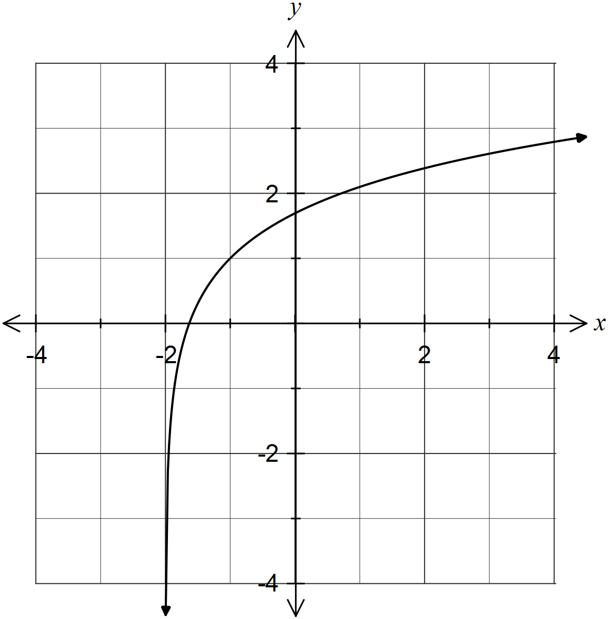

(a) Determine the function , the inverse of , and add a sketch of the graph of  to the axes above. (4 marks)

(b) Determine the area of the region bounded by the graphs of  and . (3 marks)

Question 15 (6 marks)

In the diagram, arc  subtends  radians () in a circle of radius 1 unit and centre .

The point  lies on  extended so that  is a tangent to the circle at  and the point  lies on  so that  is perpendicular to .

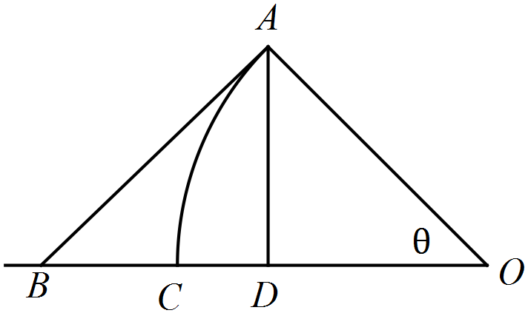

(a) By comparing the lengths of ,  and , establish the inequalities .

(3 marks)

(b) Use the inequalities  to show that as , . (3 marks)

Question 16 (11 marks)

A pyramid has its vertex  at  and the corners of its square base  at , ,  and  respectively.

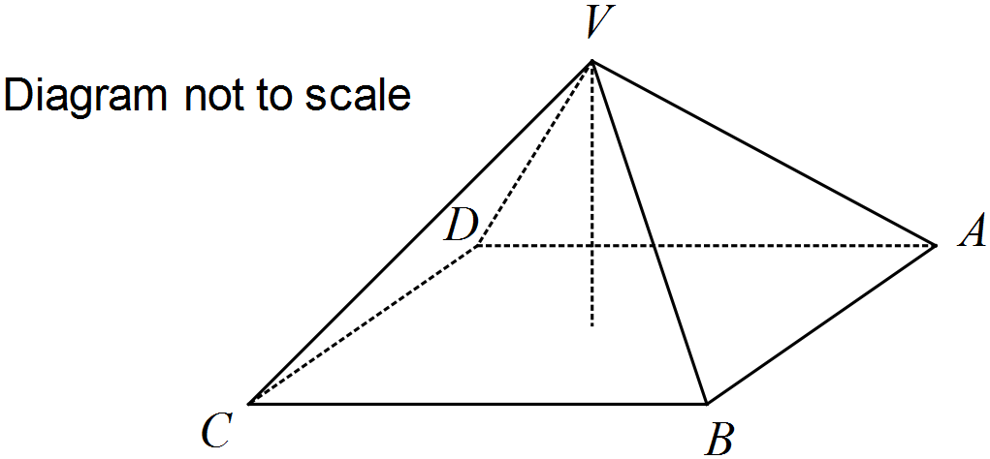

(a) Determine the position vectors of

(i) , the midpoint of side . (1 mark)

(ii) , the point of intersection of the diagonals of the square base. (1 mark)

(b) Show that  is perpendicular to both  and . (3 marks)

(c) Calculate the angle between the square base  and the sloping face . (3 marks)

(d) Determine the volume of the pyramid. (3 marks)

Question 17 (7 marks)

In the diagram below,  are midpoints of the sides of the quadrilateral .

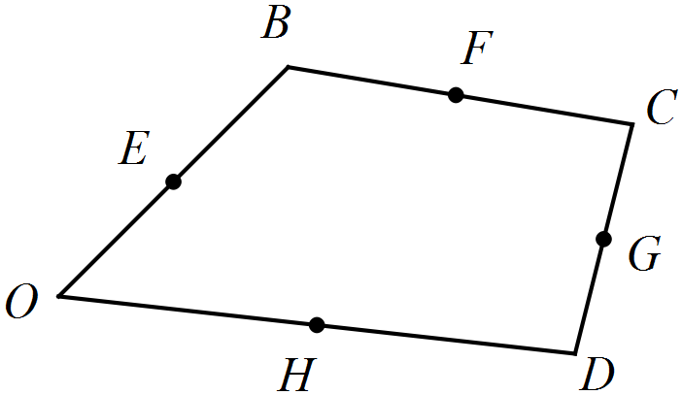

Let .

(a) Show that . (2 marks)

(b) Determine  in terms of . (2 marks)

(c) Prove that  is a parallelogram. (3 marks)

Question 18 (7 marks)

As water slowly leaks out of a hole in the bottom of a cylindrical tank, the rate of change of the depth of water in the tank,  cm, can be modelled by the differential equation ,  where  is the time in seconds and .

Initially, the depth of water in the can was 36 cm.

(a) Show that . (4 marks)

(b) Determine the rate at which the depth of water in the tank is decreasing after ten minutes.

(3 marks)

Question 19 (10 marks)

(a) Consider the mathematical statements  and , for all real numbers  and . Briefly explain why one of these statements is an axiom and the other is a theorem. (2 marks)

(b) One of the following three mathematical statements is true and the other two are false.

Determine which the true statement is and justify your answer. (3 marks)

A: If  is a positive integer, then  is never a multiple of 5.

B: If  is a positive integer, then  is a prime number.

C: If  is a positive integer, then  is never a multiple of 3.

(c) Prove by exhaustion that  for all real numbers  and , . (5 marks)

Additional working space

Question number: _________

Additional working space

Question number: _________

This examination paper may be freely copied, or communicated on an intranet, for non-commercial purposes within educational institutes that have purchased the paper from WA Examination Papers provided that WA Examination Papers is acknowledged as the copyright owner. Teachers within Rossmoyne Senior High School may change the paper provided that WA Examination Paper's moral rights are not infringed.

Copying or communication for any other purposes can only be done within the terms of the Copyright Act or with prior written permission of WA Examination papers.

*Published by WA Examination Papers*

*PO Box 445 Claremont WA 6910*